Microsoft Autopilot deployment Work Instructions for Self-Deploy Shared Devices
Deployment time from initialization to completion
Less than 4 hours. Deployment should not go beyond 4 hours.

Steps to prepare device for provisioning
- Plug in network
- Plug in power
- Check that network and power are functioning

Steps to initialize and execute Windows Autopilot for shared devices deployment
- Power on device
- On first boot the first OOBE screen will display a Welcome screen , DO NOT do anything! The process is fully automated.
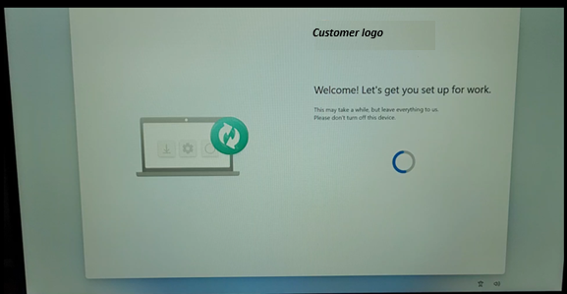
- The following screens will be displayed showing the progression of the pre-provisioning process:
Provisioning process started:
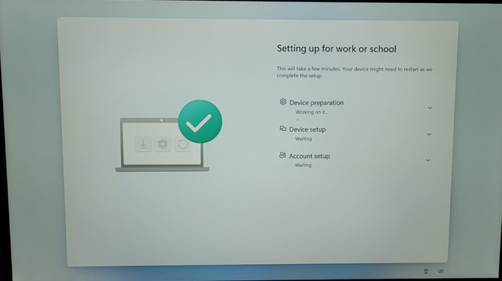
Provisioning completed (but not ready yet for shutdown)
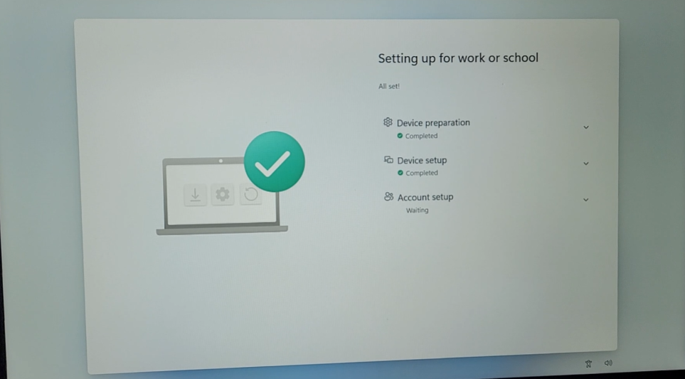

Windows Logon screen is displayed: just wait…
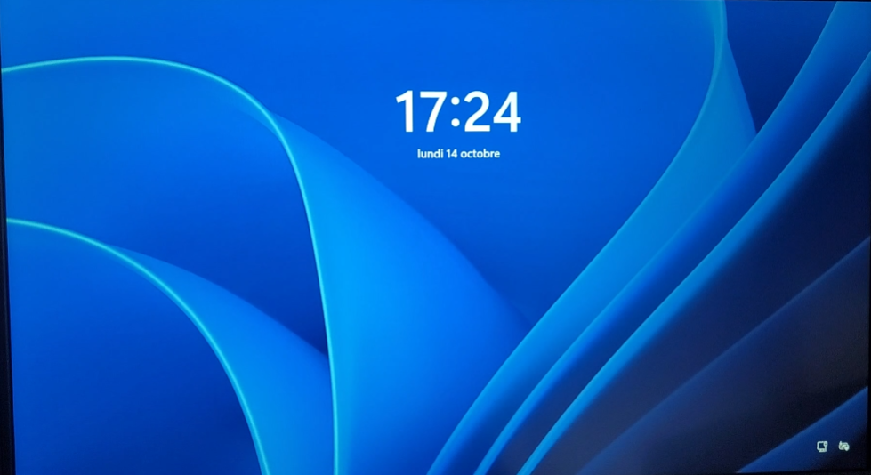
Device reboots automatically after around 2 or 3 minutes
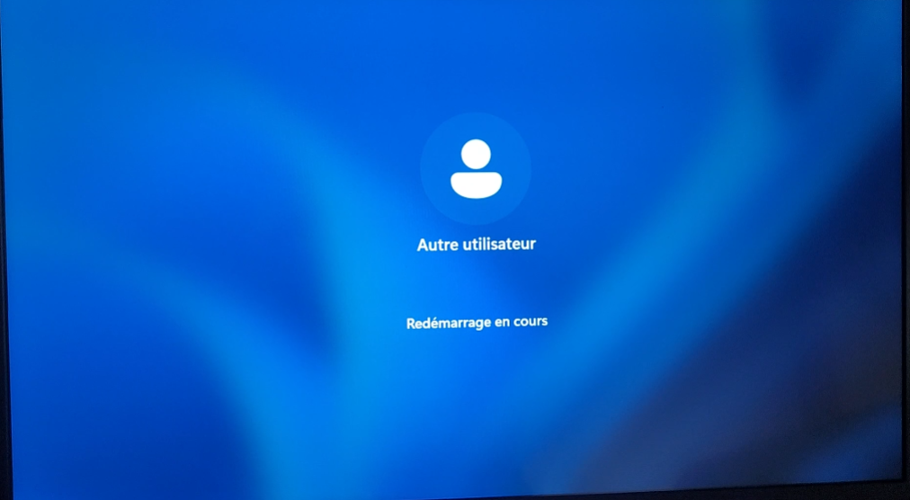

At next reboot: the deployment is completed with success if you see the lock screen with a green triangle at top left corner as seen below:


How to verify a deployment is complete and ready to ship?
- A successful provisioning deployment will result in lock screen
with a green triangle at top left corner as seen below.
At this stage, shutdown the device following the instructions as below:
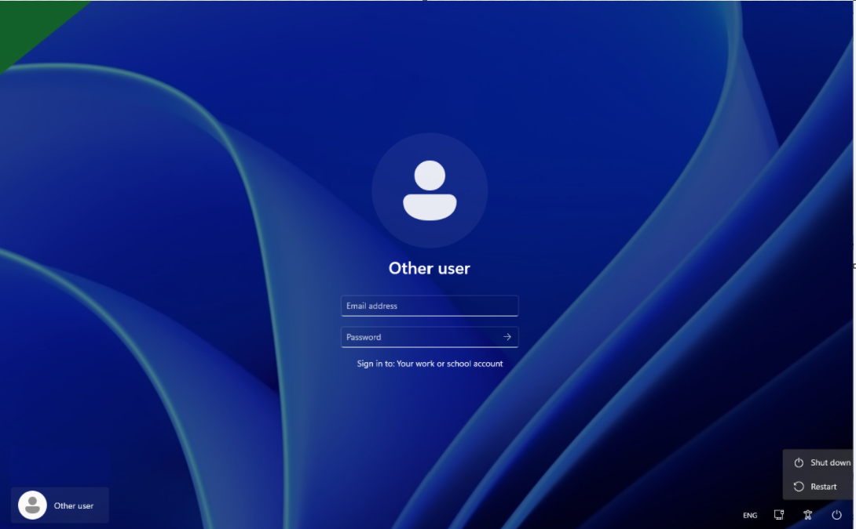
- Click on Power Icon button.
- Then click on Shutdown option to shut the device down.
The device can be boxed and shipped.

Failures/Errors
What to do for failures/errors?
- If the provisioning process fails an error/red status screen will be displayed, DO NOT CLICK “Reset device” OR “Try again”:
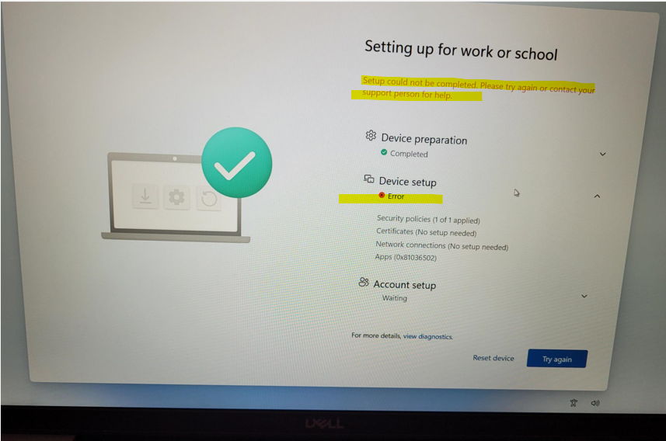
- Collect Diagnostic logs from the failed device

